h

Return Iterator

rm2

rm

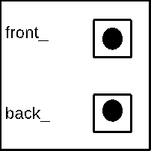



23



15



10



8

